**Local storage application(sử dụng bộ lưu trữ cục bộ của trình duyệt)**

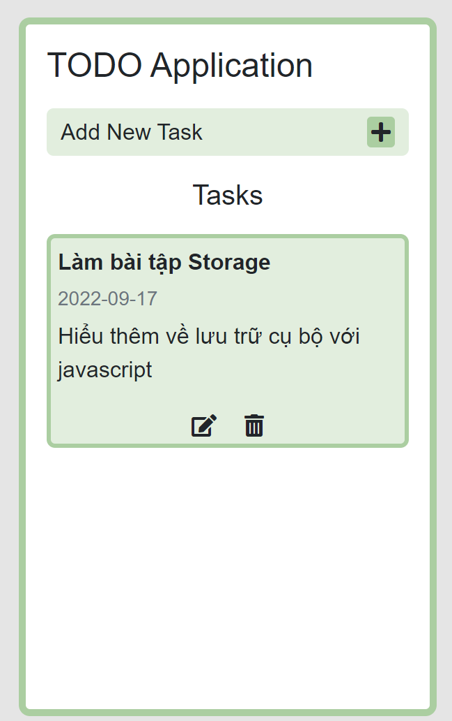

**Cấu trúc project (file style.css và index.html)**

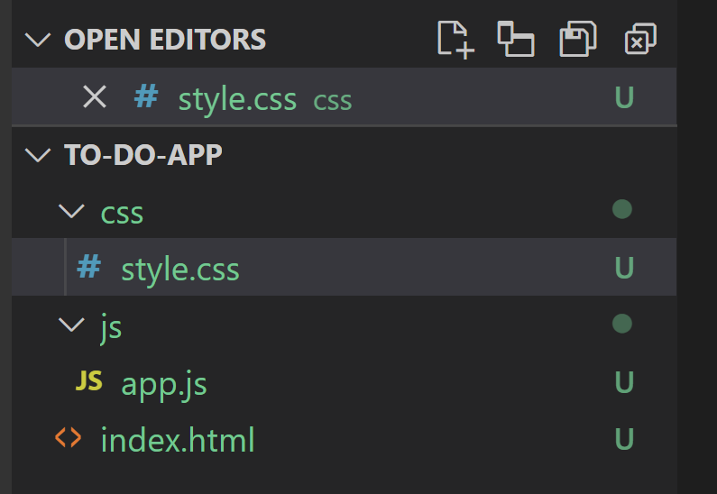

**Index.html**

**Import CND: jQuery, fontawesome, bootstrap**

**<head>**

**<link rel="stylesheet" href="https://cdnjs.cloudflare.com/ajax/libs/font-awesome/5.15.4/css/all.min.css" />**

**<meta charset="UTF-8">**

**<meta http-equiv="X-UA-Compatible" content="IE=edge">**

**<meta name="viewport" content="width=device-width, initial-scale=1.0"> <title>TODO App</title>**

**<link** [**href="https://cdn.jsdelivr.net/npm/bootstrap@5.1.3/dist/css/bootstrap.min.css**](mailto:href="https://cdn.jsdelivr.net/npm/bootstrap@5.1.3/dist/css/bootstrap.min.css)**" rel="stylesheet" integrity="sha3841BmE4kWBq78iYhFldvKuhfTAU6auU8tT94WrHftjDbrCEXSU1oBoqyl2QvZ6jIW"crossorigin="anonymous">**

**<link rel="stylesheet" href="css/style.css">**

**</head>**

**Index.html**

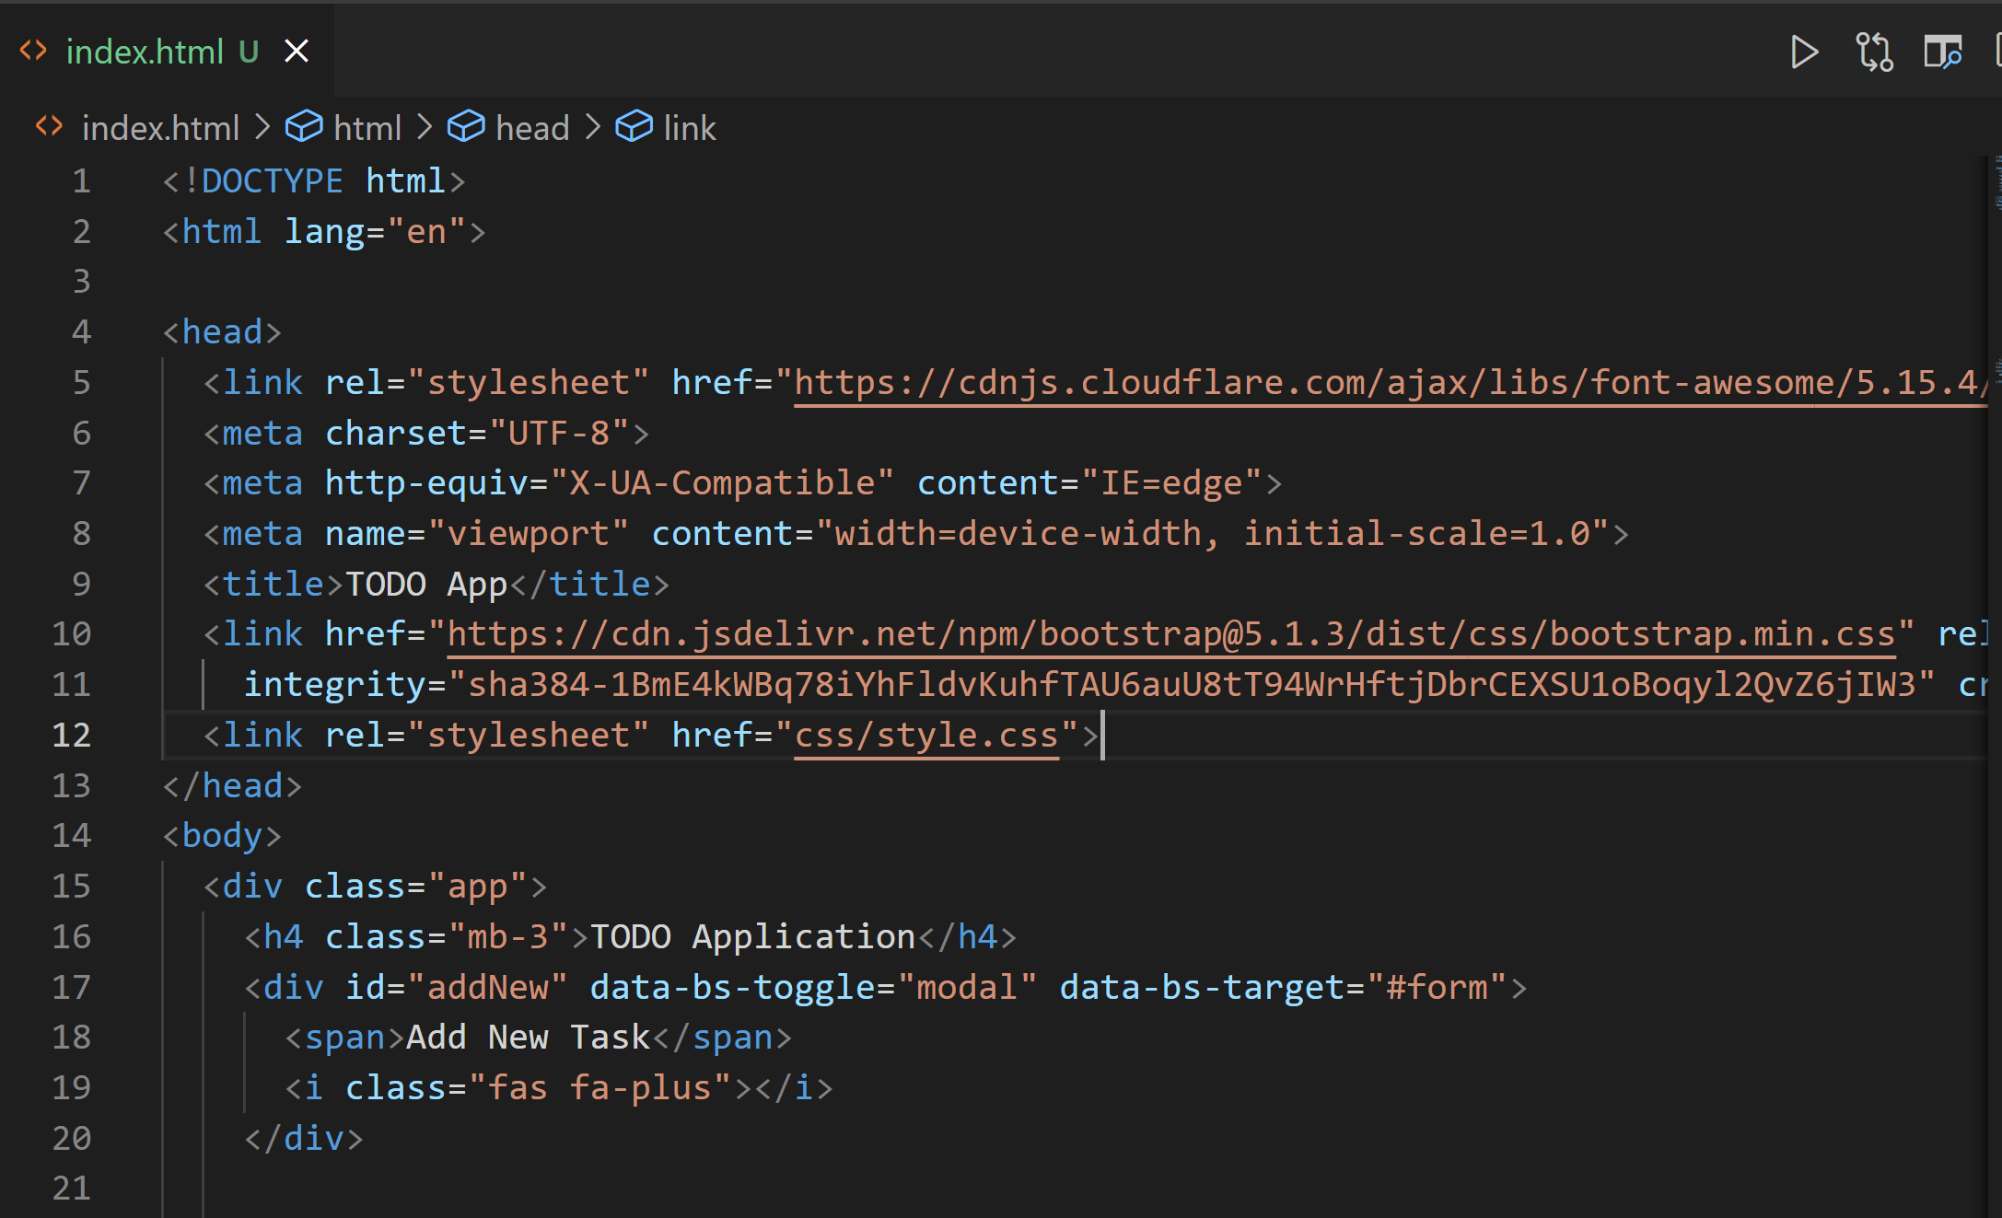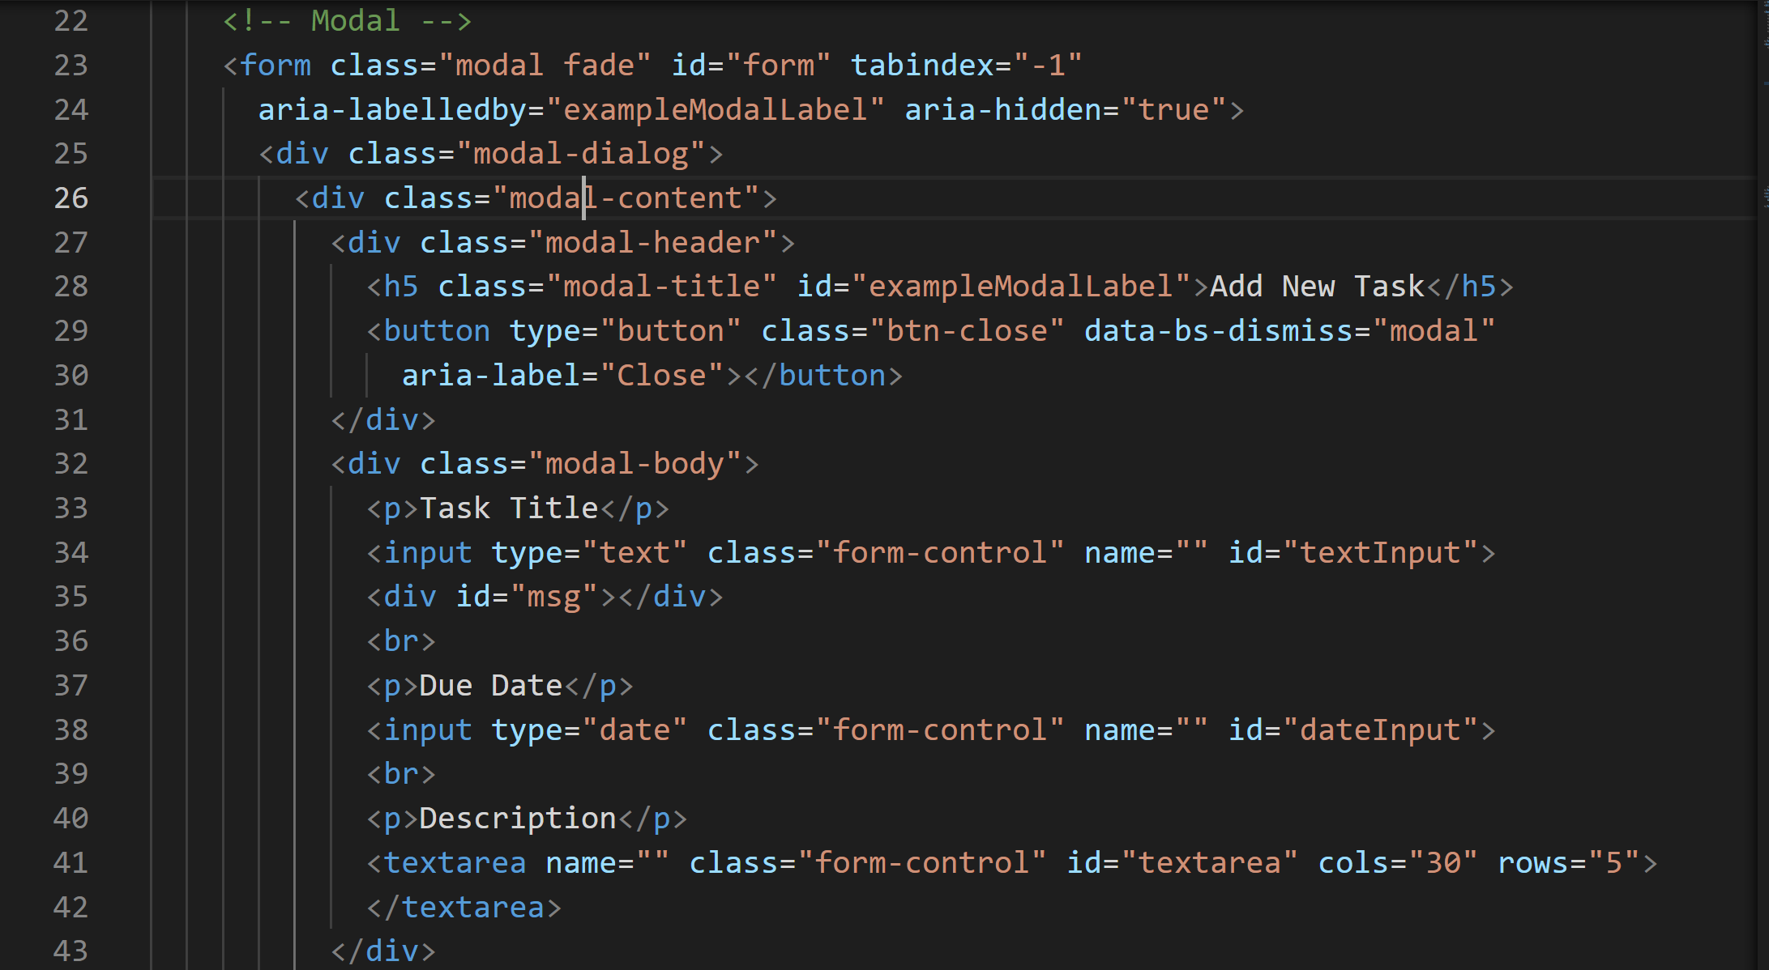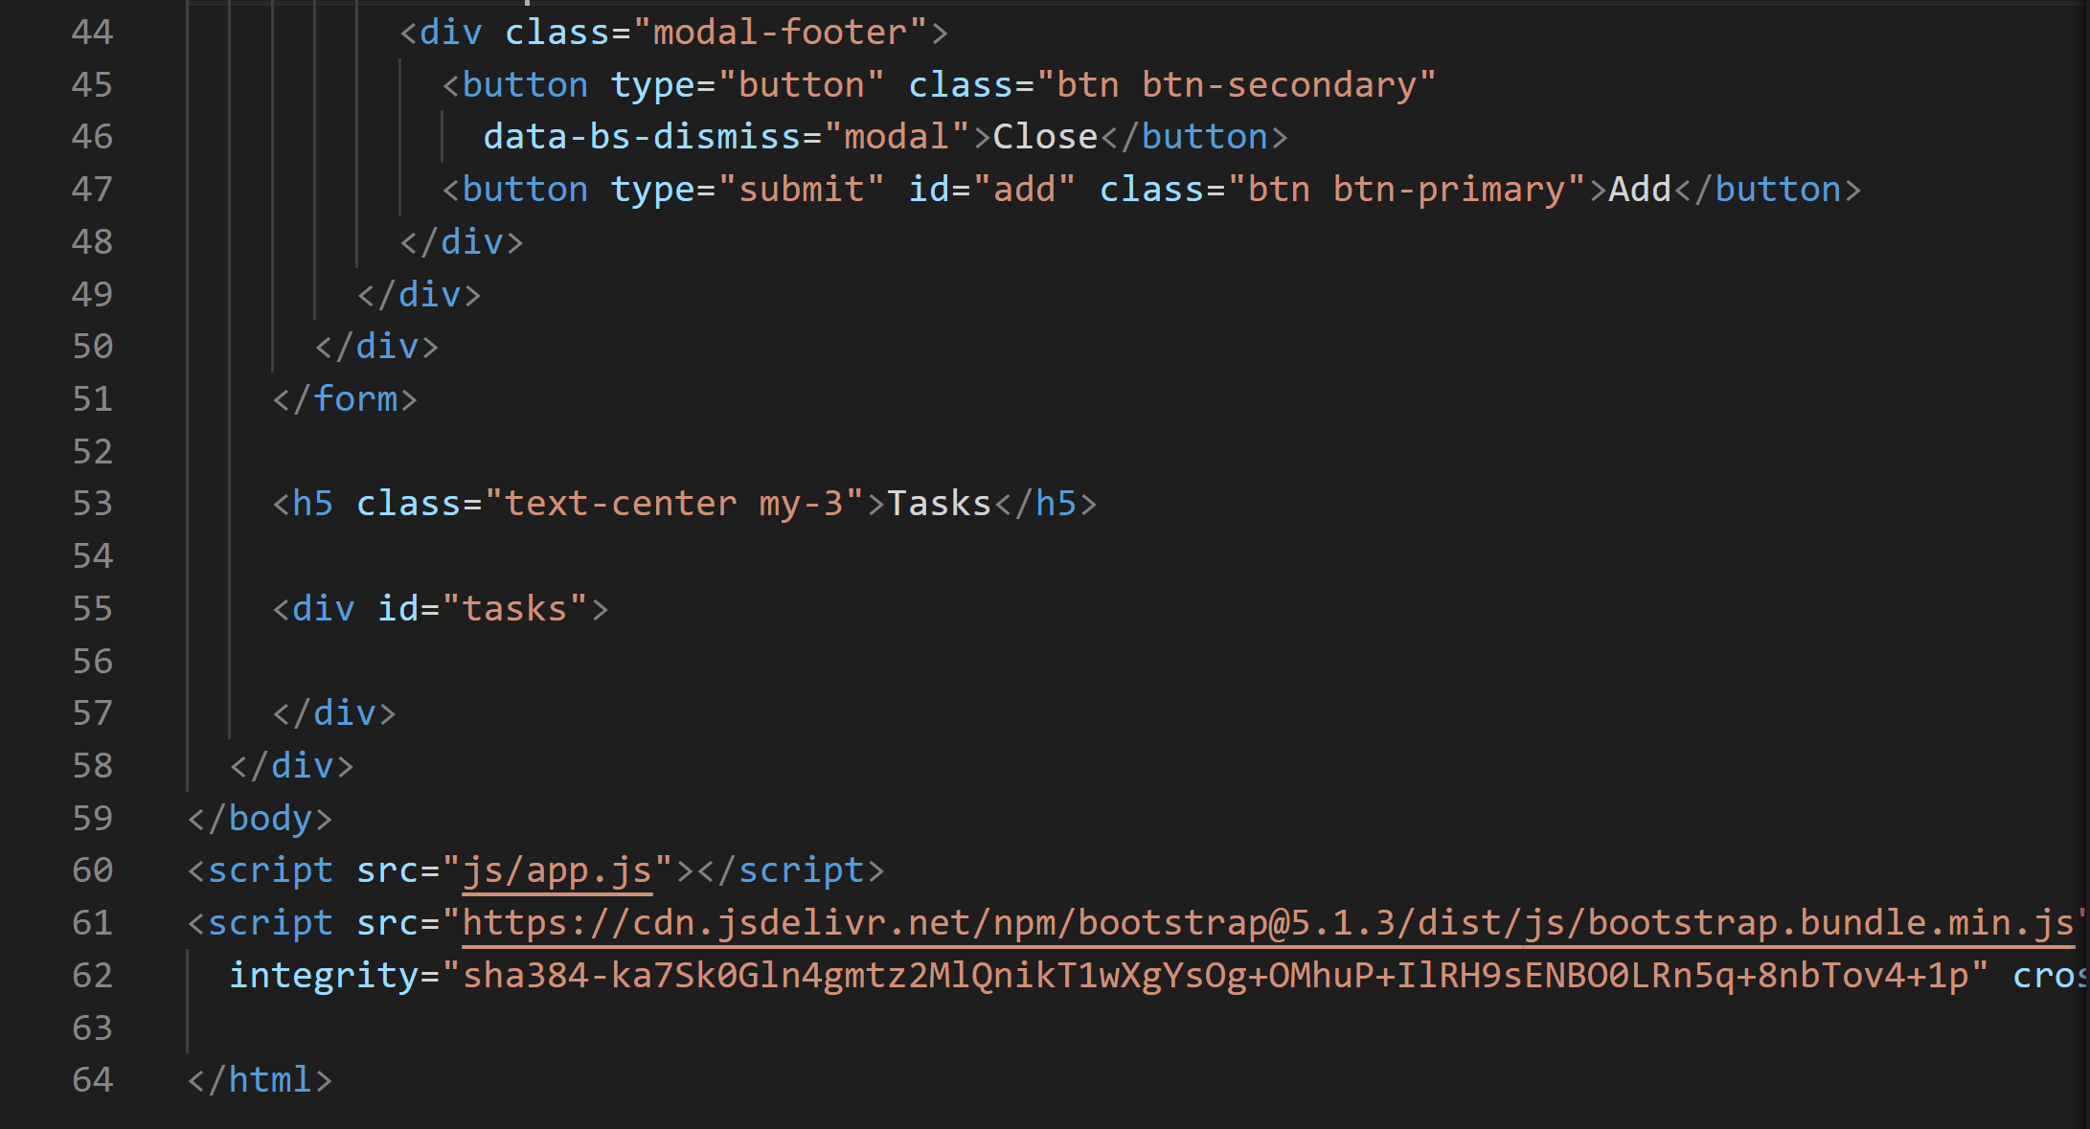

CDN: Bootstrap javaScript

**<script src="https://cdn.jsdelivr.net/npm/bootstrap@5.1.3/dist/js/bootstrap.bundle.min.j"integrity="sha384ka7Sk0Gln4gmtz2MlQnikT1wXgYsOg+OMhuP+IlRH9sENBO0LRn5q+8nbTov4+1" crossorigin="anonymous"></script>**

**style.css**

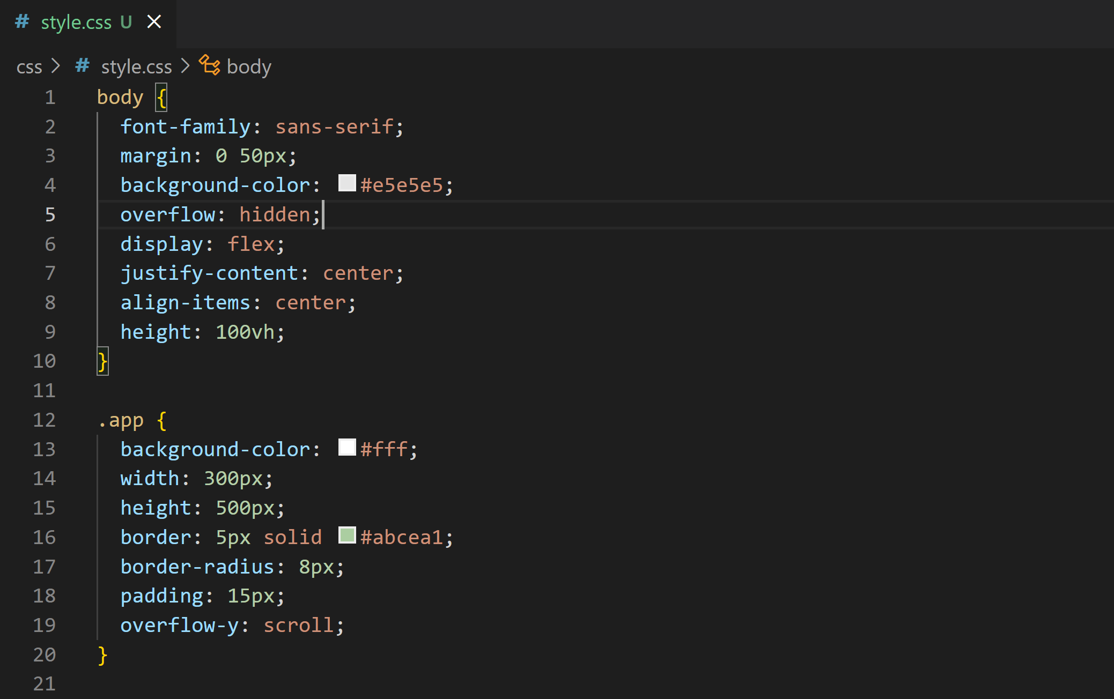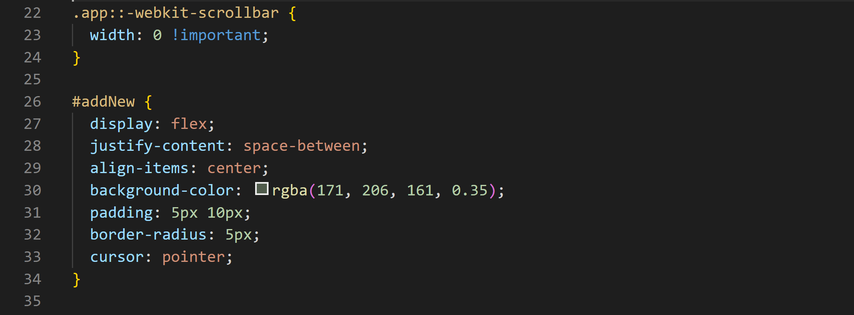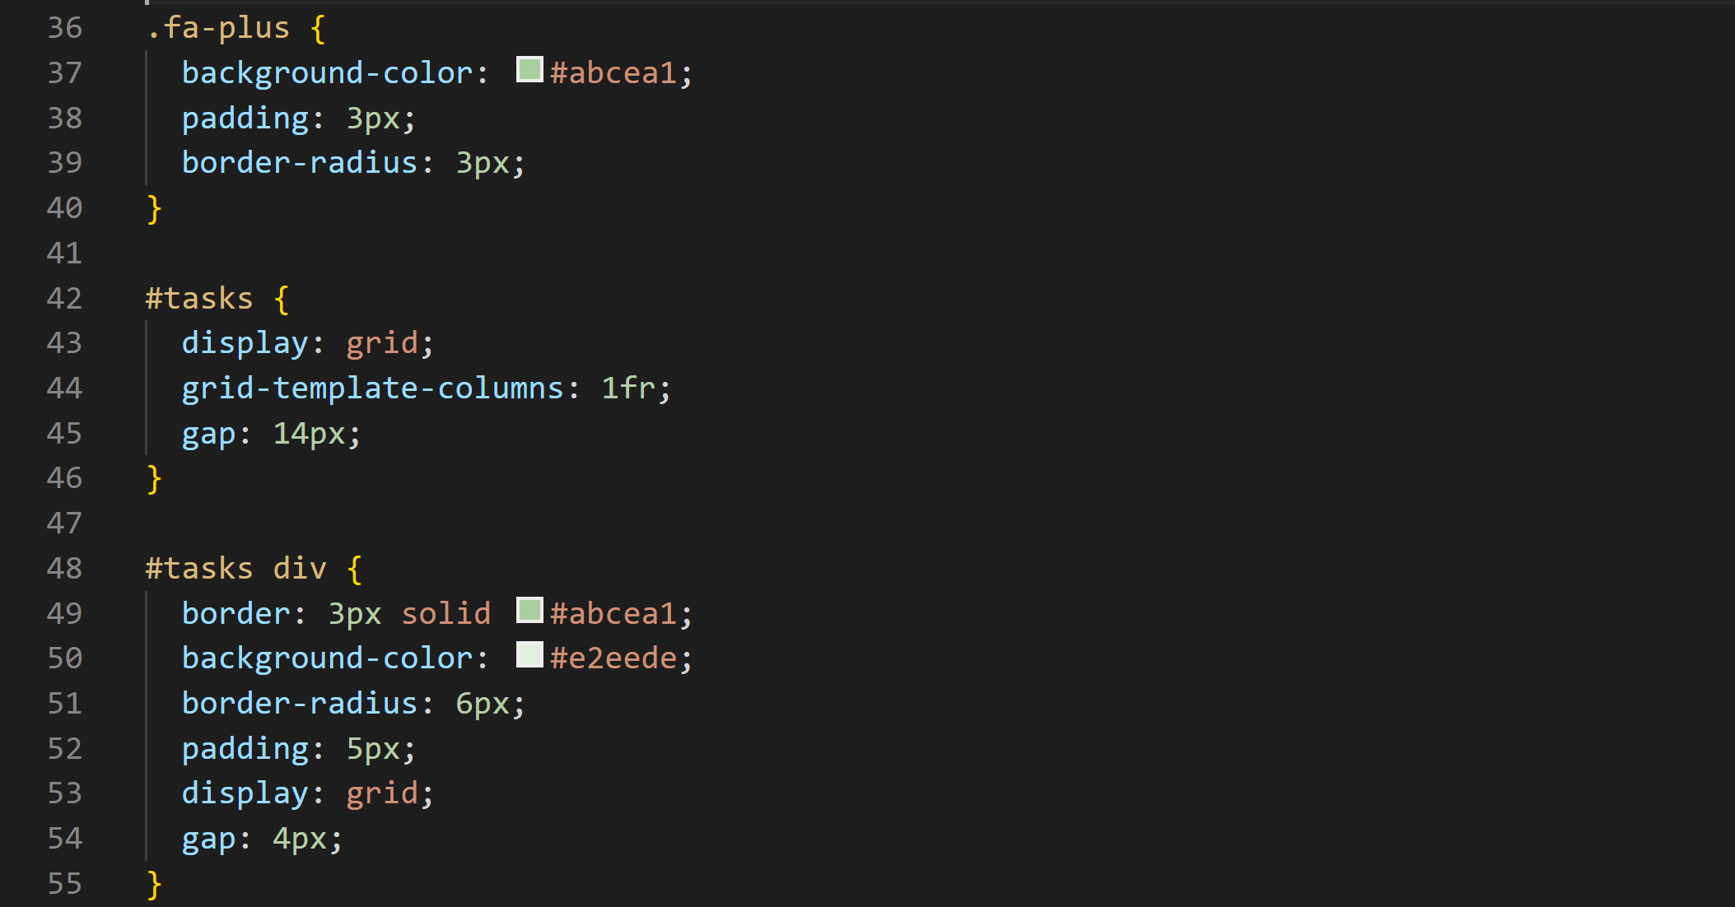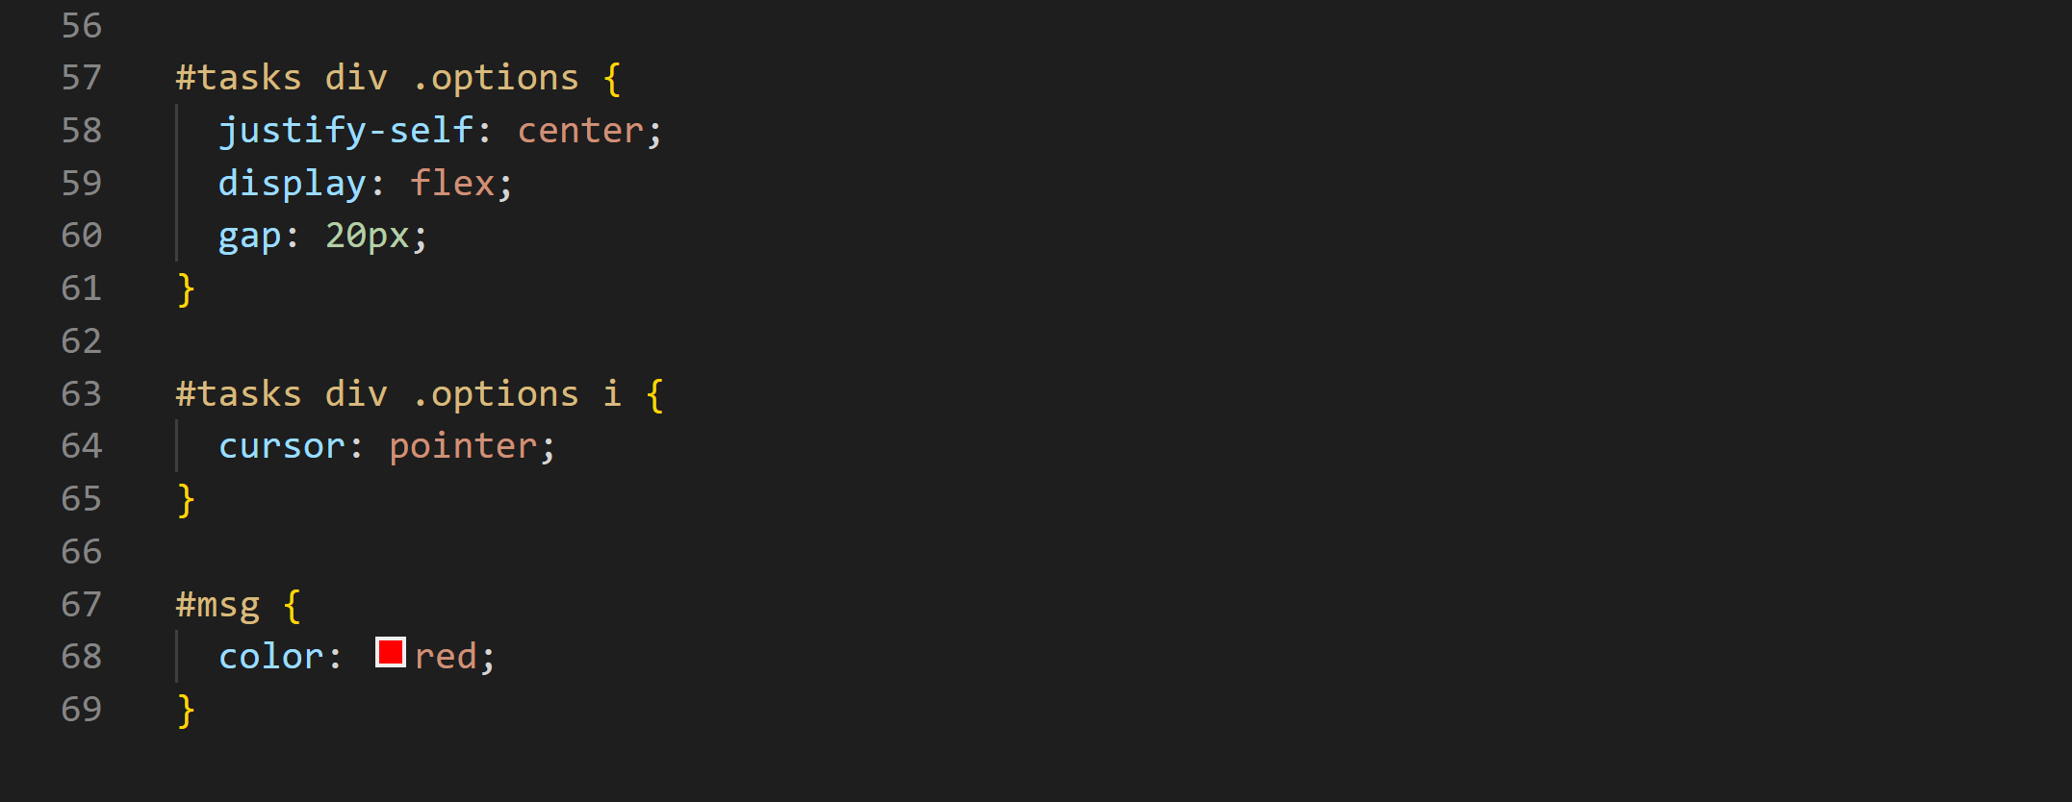

**File app.js**

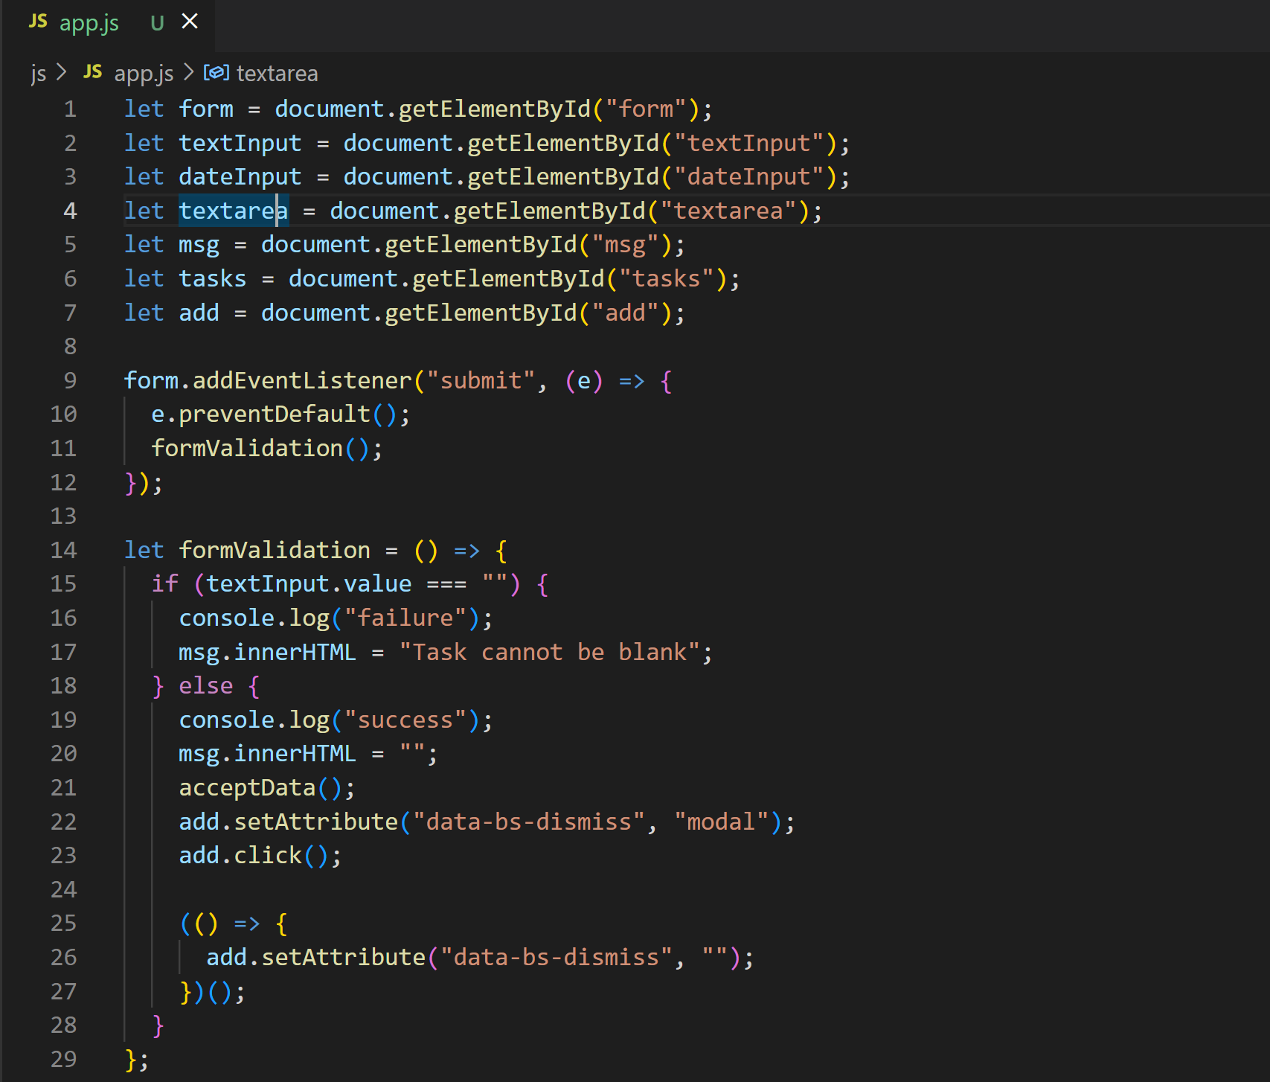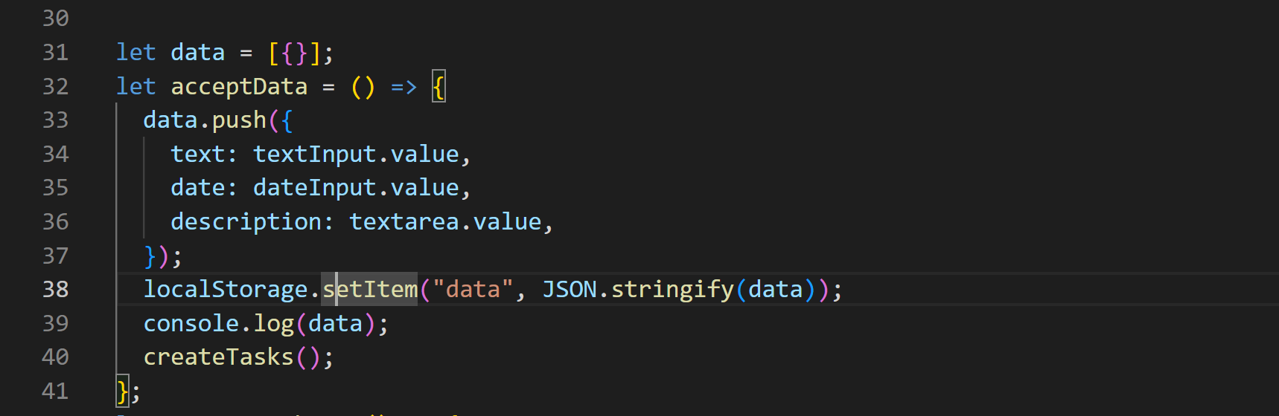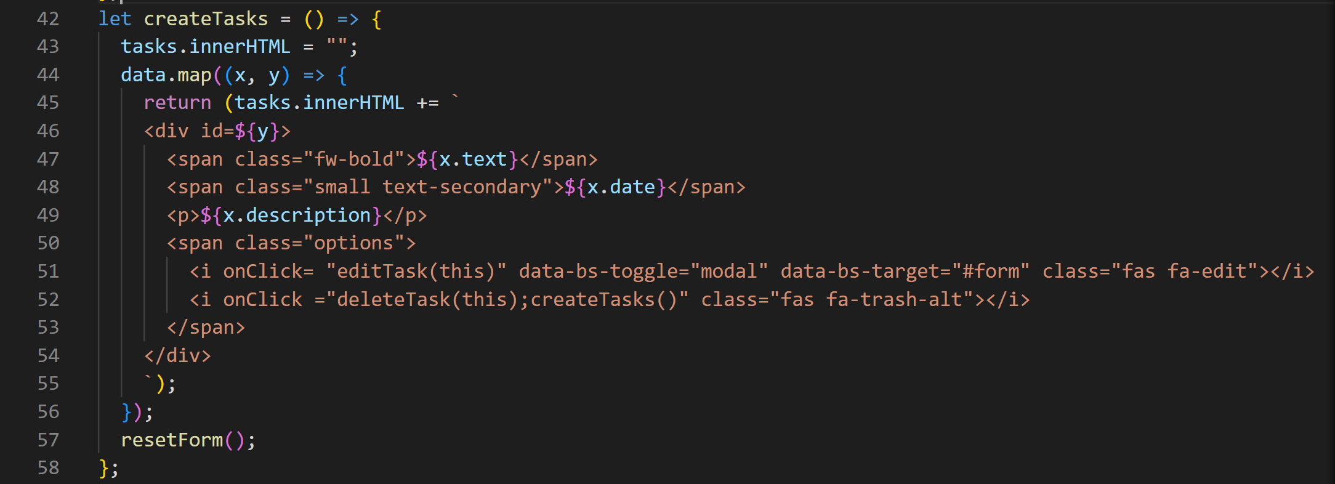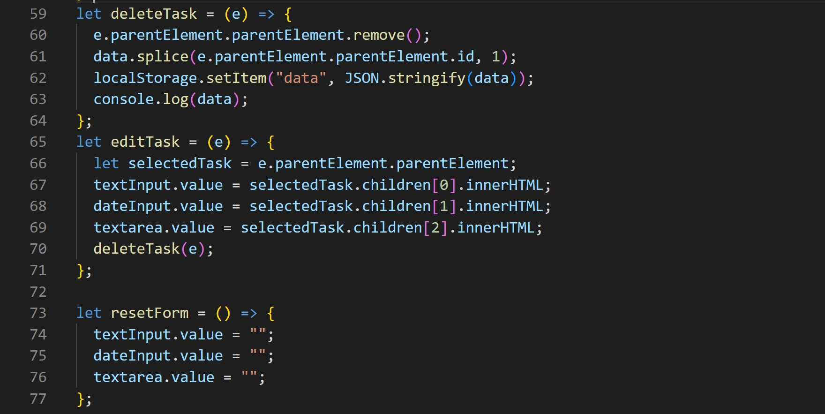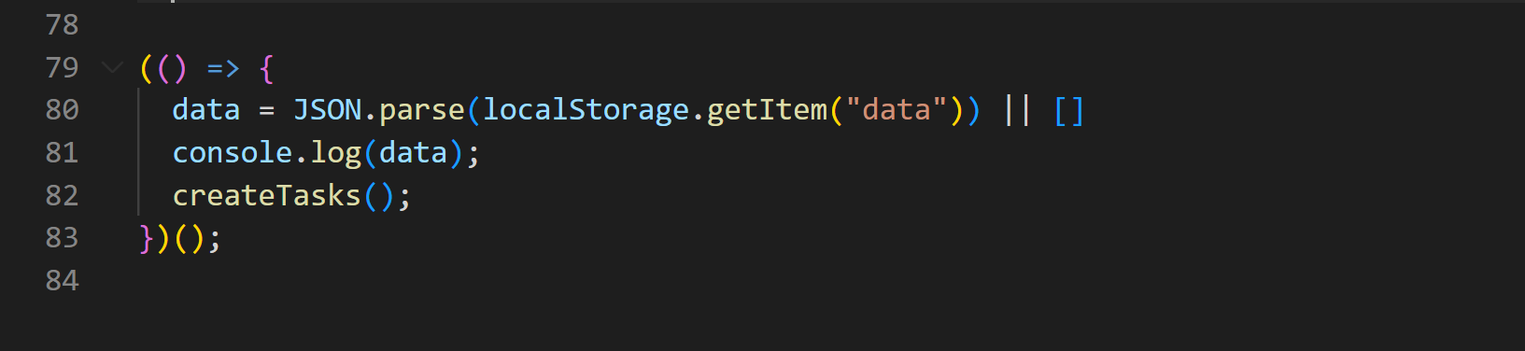

**===end of tutorial==**